**LAB ASSIGNMENT-2**

Submitted for

**COMPILER CONSTRUCTION (UCS802)**

Submitted by

**Divesh Goel**

**102103147**

**4 COE 5**



Computer Science and Engineering Department

Thapar Institute of Engineering and Technology, Patiala

**QUESTION:**

Design a SLR parser for the grammar given below:

E→E+T/T

T→T*F/F F→(E)/id

**JAVA CODE:**

import java.util.*;

class Action {

String type;

int state;

Action(String type, int state) {

this.type = type;

this.state = state;

}

}

public class Compiler {

static Map<Integer, Map<String, Action>> actionTable = new HashMap<>();

static Map<Integer, Map<String, Integer>> gotoTable = new HashMap<>();

static Map<String, Set<String>> firstSet = new HashMap<>();

static Map<String, Set<String>> followSet = new HashMap<>();

static Map<Integer, Pair<String, Integer>> productions = new HashMap<>();

static class Pair<T, U> {

T first;

U second;

Pair(T first, U second) {

this.first = first;

this.second = second;

}

}

static {

actionTable.put(0, new HashMap<>() {{ put("id", new Action("shift", 5)); put("(", new Action("shift", 4)); }});

actionTable.put(1, new HashMap<>() {{ put("+", new Action("shift", 6)); put("$", new Action("accept", 0)); }});

actionTable.put(2, new HashMap<>() {{ put("+", new Action("reduce", 2)); put("*", new Action("shift", 7)); put(")", new Action("reduce", 2)); put("$", new Action("reduce", 2)); }});

actionTable.put(3, new HashMap<>() {{ put("+", new Action("reduce", 4)); put("*", new Action("reduce", 4)); put(")", new Action("reduce", 4)); put("$", new Action("reduce", 4)); }});

actionTable.put(4, new HashMap<>() {{ put("id", new Action("shift", 5)); put("(", new Action("shift", 4)); }});

actionTable.put(5, new HashMap<>() {{ put("+", new Action("reduce", 6)); put("*", new Action("reduce", 6)); put(")", new Action("reduce", 6)); put("$", new Action("reduce", 6)); }});

actionTable.put(6, new HashMap<>() {{ put("id", new Action("shift", 5)); put("(", new Action("shift", 4)); }});

actionTable.put(7, new HashMap<>() {{ put("id", new Action("shift", 5)); put("(", new Action("shift", 4)); }});

actionTable.put(8, new HashMap<>() {{ put("+", new Action("shift", 6)); put(")", new Action("shift", 11)); }});

actionTable.put(9, new HashMap<>() {{ put("+", new Action("reduce", 1)); put("*", new Action("shift", 7)); put(")", new Action("reduce", 1)); put("$", new Action("reduce", 1)); }});

actionTable.put(10, new HashMap<>() {{ put("+", new Action("reduce", 3)); put("*", new Action("reduce", 3)); put(")", new Action("reduce", 3)); put("$", new Action("reduce", 3)); }});

actionTable.put(11, new HashMap<>() {{ put("+", new Action("reduce", 5)); put("*", new Action("reduce", 5)); put(")", new Action("reduce", 5)); put("$", new Action("reduce", 5)); }});

gotoTable.put(0, new HashMap<>() {{ put("E", 1); put("T", 2); put("F", 3); }});

gotoTable.put(4, new HashMap<>() {{ put("E", 8); put("T", 2); put("F", 3); }});

gotoTable.put(6, new HashMap<>() {{ put("T", 9); put("F", 3); }});

gotoTable.put(7, new HashMap<>() {{ put("F", 10); }});

firstSet.put("E", new HashSet<>() {{ add("id"); add("("); }});

firstSet.put("T", new HashSet<>() {{ add("id"); add("("); }});

firstSet.put("F", new HashSet<>() {{ add("id"); add("("); }});

followSet.put("E", new HashSet<>() {{ add(")"); add("+"); add("$"); }});

followSet.put("T", new HashSet<>() {{ add("+"); add("*"); add(")"); add("$"); }});

followSet.put("F", new HashSet<>() {{ add("*"); add("+"); add(")"); add("$"); }});

productions.put(0, new Pair<>("E'", 1));

productions.put(1, new Pair<>("E", 3));

productions.put(2, new Pair<>("E", 1));

productions.put(3, new Pair<>("T", 3));

productions.put(4, new Pair<>("T", 1));

productions.put(5, new Pair<>("F", 3));

productions.put(6, new Pair<>("F", 1));

}

public static void main(String[] args) {

printFirstAndFollowSets();

printActionAndGotoTables();

System.out.println("\nThe input string to parse: id + id * F");

String[] inputTokens = {"id", "+", "id", "*", "F", "$"};

slrParser(inputTokens);

}

static void printFirstAndFollowSets() {

System.out.println("FIRST Sets:");

for (Map.Entry<String, Set<String>> entry : firstSet.entrySet()) {

System.out.printf("FIRST(%s) = { %s }%n", entry.getKey(), String.join(" ", entry.getValue()));

}

System.out.println("\nFOLLOW Sets:");

for (Map.Entry<String, Set<String>> entry : followSet.entrySet()) {

System.out.printf("FOLLOW(%s) = { %s }%n", entry.getKey(), String.join(" ", entry.getValue()));

}

}

static void printActionAndGotoTables() {

String[] terminals = {"id", "+", "*", "(", ")", "$"};

String[] nonTerminals = {"E", "T", "F"};

System.out.println("ACTION Table:");

System.out.print(String.format("%-10s", "State"));

for (String term : terminals) {

System.out.print(String.format("%-15s", term));

}

System.out.println();

System.out.println("-".repeat(10 + terminals.length * 15));

for (int state : actionTable.keySet()) {

System.out.printf(String.format("%-10d", state));

for (String term : terminals) {

Action action = actionTable.get(state).get(term);

if (action != null) {

if (action.type.equals("shift")) {

System.out.printf(String.format("%-15s", "s" + action.state));

} else if (action.type.equals("reduce")) {

System.out.printf(String.format("%-15s", "r" + action.state));

} else if (action.type.equals("accept")) {

System.out.printf(String.format("%-15s", "acc"));

}

} else {

System.out.print(String.format("%-15s", ""));

}

}

System.out.println();

}

System.out.println("\nGOTO Table:");

System.out.print(String.format("%-10s", "State"));

for (String nonTerm : nonTerminals) {

System.out.print(String.format("%-15s", nonTerm));

}

System.out.println();

System.out.println("-".repeat(10 + nonTerminals.length * 15));

for (int state : gotoTable.keySet()) {

System.out.printf(String.format("%-10d", state));

for (String nonTerm : nonTerminals) {

Integer nextState = gotoTable.get(state).get(nonTerm);

if (nextState != null) {

System.out.printf(String.format("%-15d", nextState));

} else {

System.out.print(String.format("%-15s", ""));

}

}

System.out.println();

}

}

static void slrParser(String[] tokens) {

Deque<Integer> stateStack = new ArrayDeque<>();

Deque<String> symbolStack = new ArrayDeque<>();

stateStack.push(0);

int i = 0;

while (true) {

int state = stateStack.peekLast();

String token = tokens[i];

if (!actionTable.get(state).containsKey(token)) {

System.out.println("Status: Rejected");

return;

}

Action action = actionTable.get(state).get(token);

if (action.type.equals("shift")) {

stateStack.push(action.state);

symbolStack.push(token);

i++;

} else if (action.type.equals("reduce")) {

Pair<String, Integer> production = productions.get(action.state);

String productionRule = production.first;

int popCount = production.second;

for (int j = 0; j < popCount; j++) {

stateStack.pop();

symbolStack.pop();

}

String nonTerminal = productionRule;

Integer nextState = gotoTable.get(stateStack.peekLast()).get(nonTerminal);

stateStack.push(nextState);

symbolStack.push(nonTerminal);

} else if (action.type.equals("accept")) {

System.out.println("Status: Accepted");

return;

}

}

}

}

**OUTPUT:**

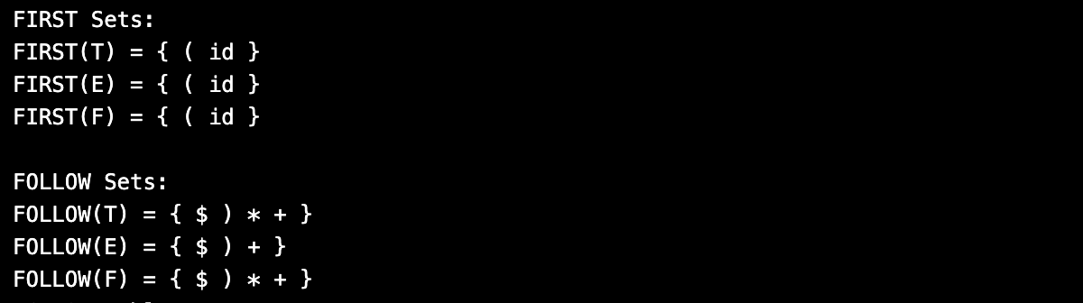

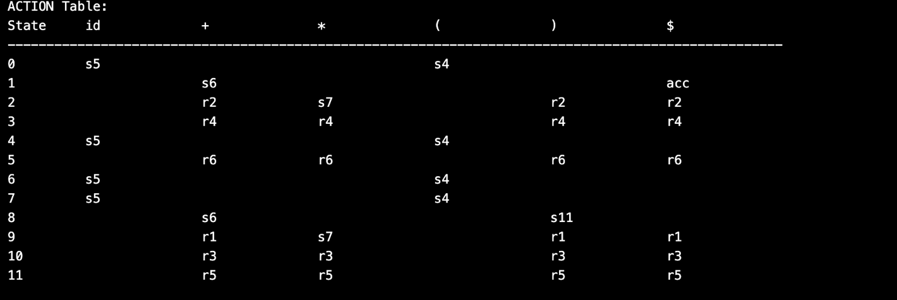

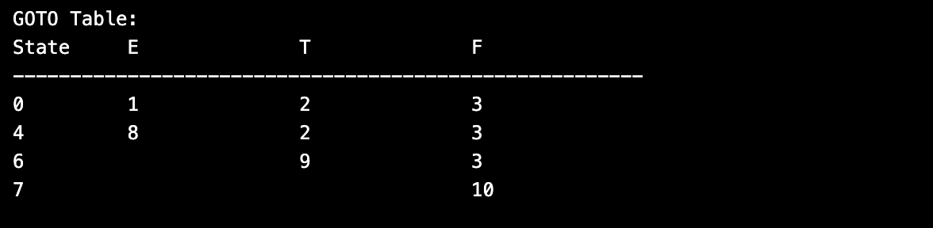

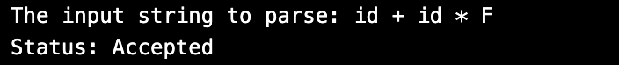

**Output when the input is id + id * ( :**

